A Dream is a Wish/Wake up Pretty Susie

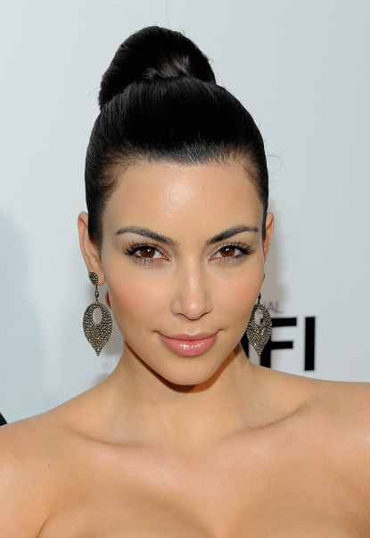

High Bun

No hair hanging in face unless you have bangs

Same hair style for both numbers. Headbands are the only things that are switched.

Dancing in the Dark/What Dreams are Made Of

High Ponytail

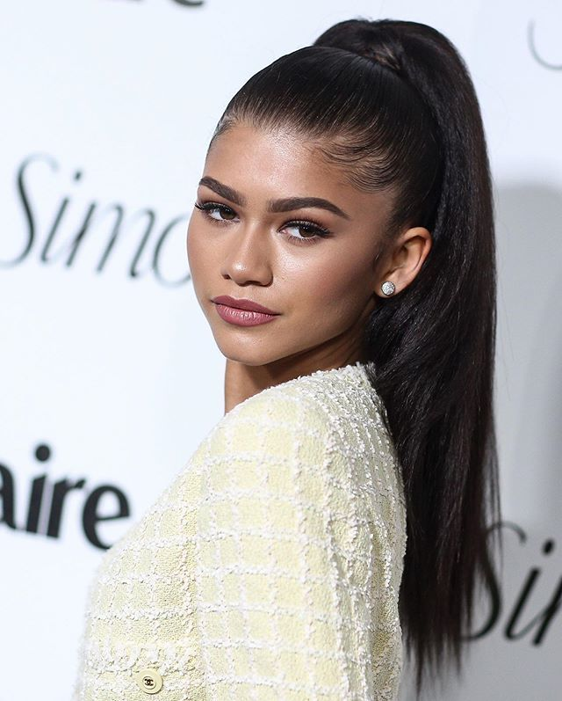

Slicked back high pony so we can see the hair cuff

You can choose whether curly or straight. Either style must be neat and hair out of the face.

Daydream Believer/ Thunder

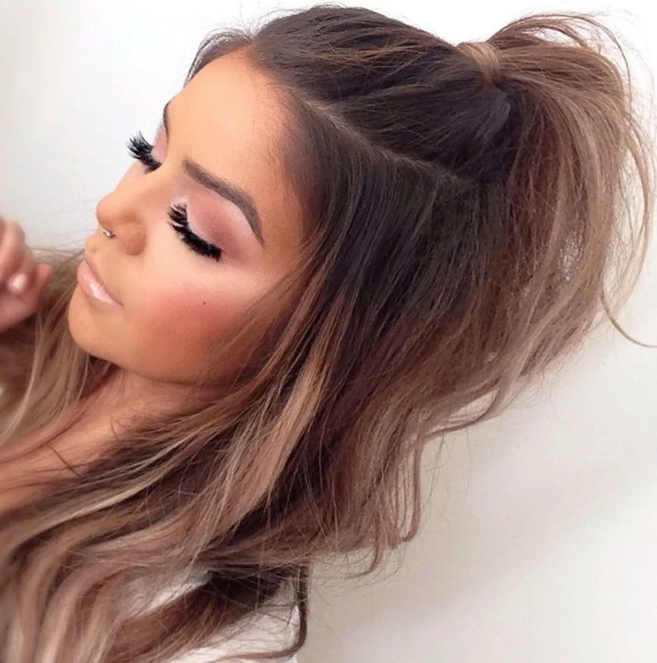

Ponytail at top of head with matching elastic to skater’s hair

Daydream Believer will have a headband added (keep ponytail in)

Thunder will have headband removed and the bow clip attached to front of ponytail

You may choose whether hair is straight or curled. Either style must be neat.

Try Everything/We Own the Night

Ponytail at top of head with elastic matching skater’s hair color

IF you are wearing a hat for Try Everything, do a low pony that can go through the back of the hat. Curled hair is preferred.

River of Dreams/You Make My Dreams Come True

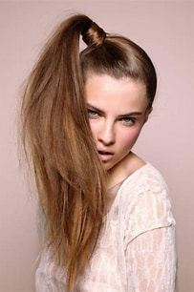

High side ponytail CURLED with elastic matching the skater’s hair. The hair does NOT have to be wrapped around the pony. Same for both numbers, just switching out the hair piece. These are 80s songs so we want a big fluffy pony! ☺

Sweet Dreams/Some Nights

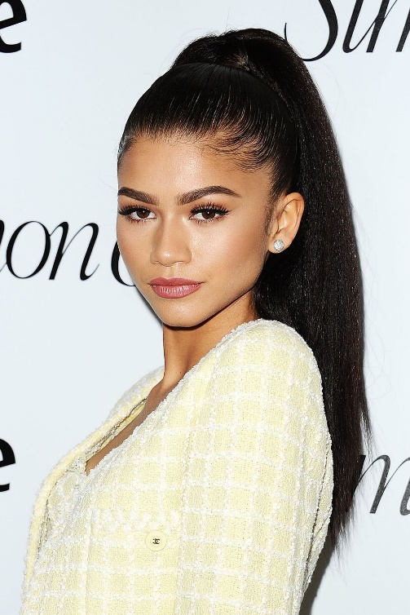

High ponytail CURLED and slicked back with no hair in face. We want it high enough to see the scrunchie from the front. Same for both numbers just switching out the ponytail cuff.

Opening

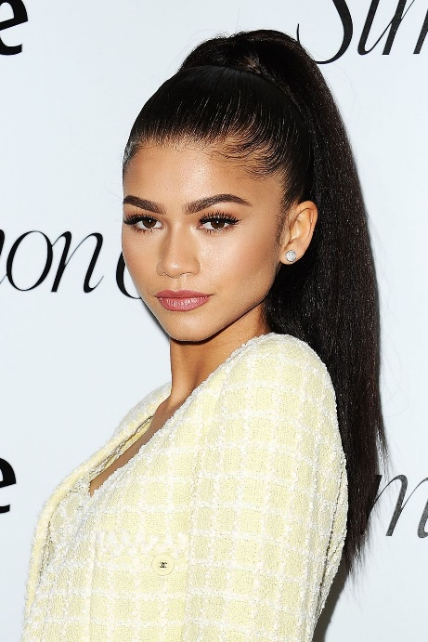

Slick back high **curled** ponytail so we can see the pony cuff from the front.

Hockey Skate

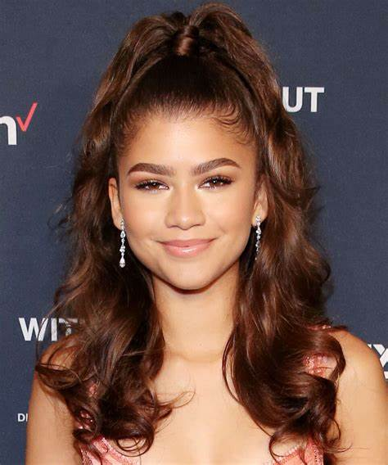

Half up half down with curls. High enough to see the gold scrunchie from the front. We want BIG HAIR!!

Adelyn & Maci Duet

Add headband to ponytail

Arabian Nights

High Curled Ponytail

Closing

Mid level ponytail

You can take out the half up half down style pony if you were in the hockey skate or leave it in and just gather hair into a pony. Whichever is easier.